Twitter Sentimental Analysis Using Azure Logic Apps

In this tutorial you will learn how to do Twitter Sentimental Analysis using a Logic App and create an incident in PagerDuty.



**Azure Logic Apps** is a cloud-based service that helps to schedule, automate tasks, business processes, and workflows when you need to integrate apps, data, systems, and services across the organizations.

**Prerequisites**: # You need to have an active Azure subscription. If you not have you can sign-up for a free [account](https://azure.microsoft.com/en-in/free/).

#You need to create a Text analytics API Key for this Project. For that you can follow up with [this](https://docs.microsoft.com/en-us/azure/cognitive-services/cognitive-services-apis-create-account?tabs=multiservice%2Cwindows).

**Task 1st**: Creating PagerDuty Free [Account](https://www.pagerduty.com/) and creating necessary keys.

1. Click on Account and create a free trail of 14 days.
2. Once you have Login to the account next step is to create a Service.

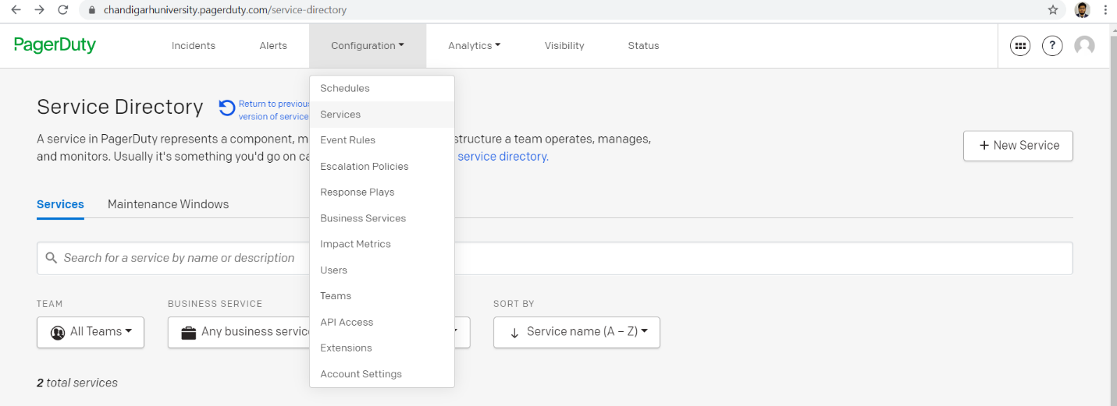

1. Now we have to fill in the details as you can see in the screenshot below. After that you will be having a Service.

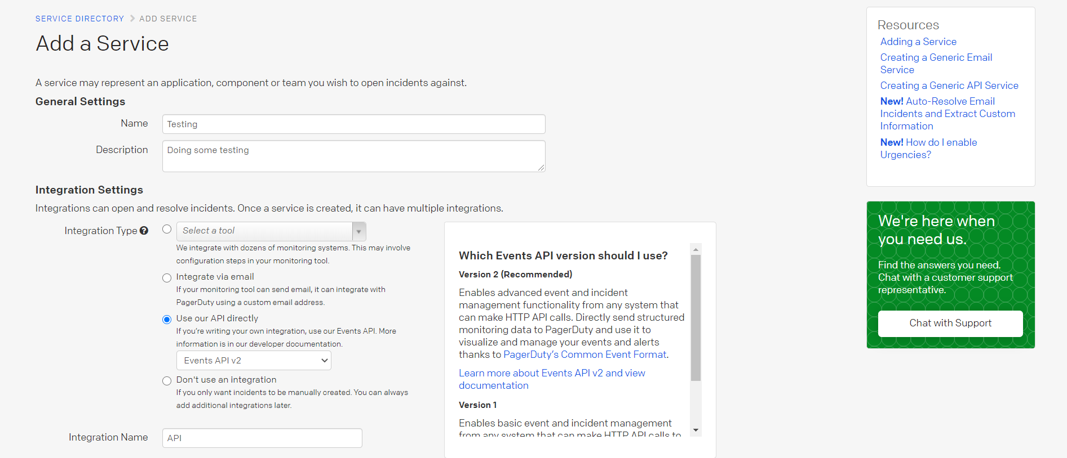

1. Next step is Integrations. As you can see in the screenshot below.

**Note**: You will get a 32-character Service Integration Key. Copy it and save it for future use.

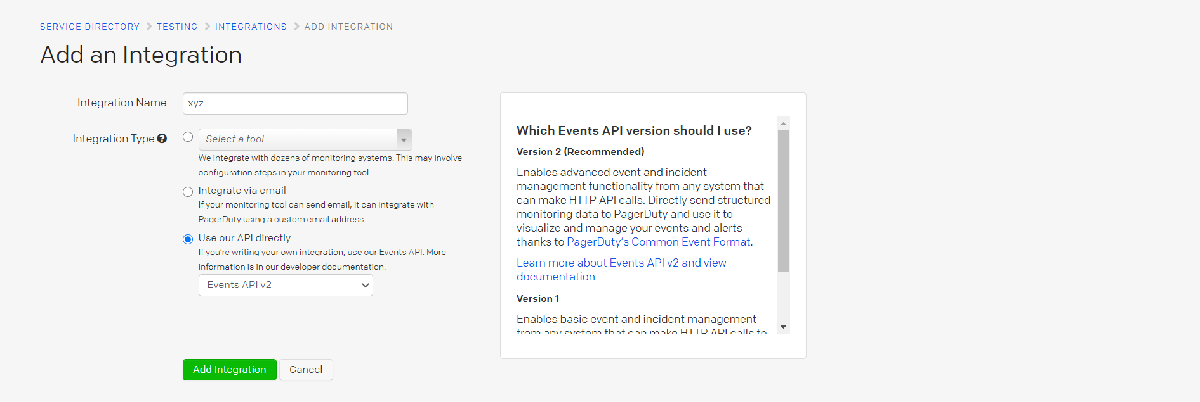

1. Once you are done in with that next task here is to generate an API Key. See below how to do that:

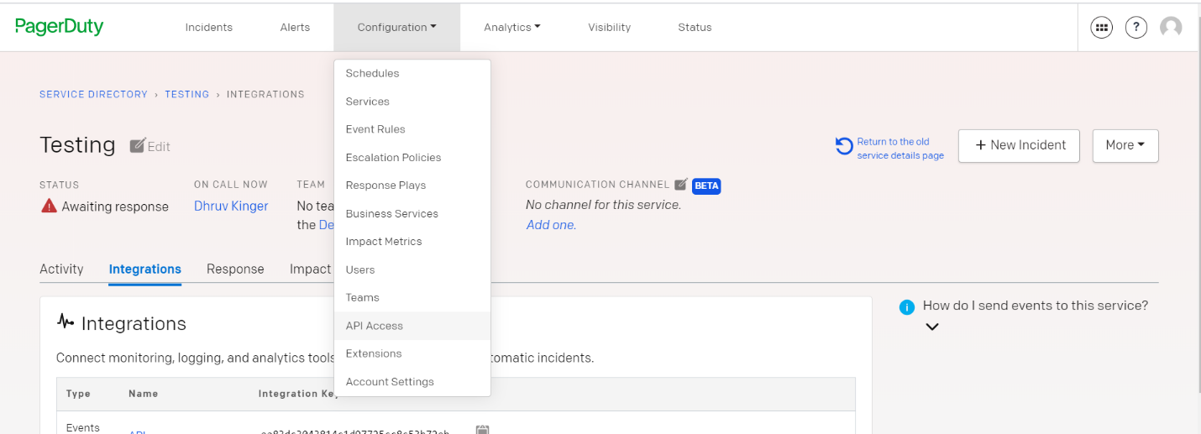

1. You will click Configuration->API Access.

**Note**: You will get a 16-character API Key. Copy it and save for future use.

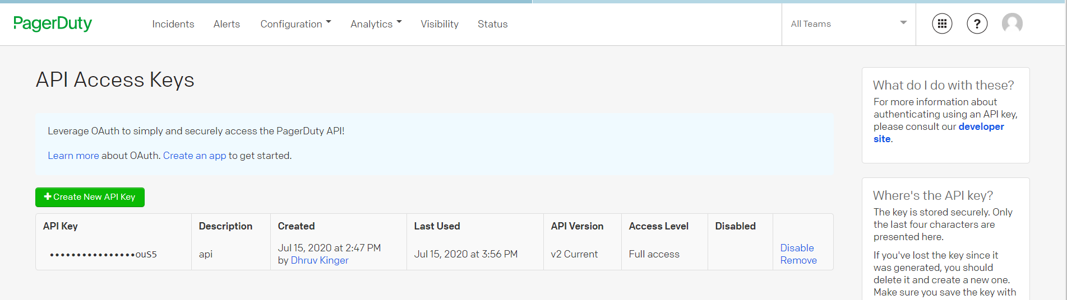

**Task 2nd**: Creating and the Logic App and creating an incident in PagerDuty.

* Navigate to Azure Portal.
* Search Logic Apps.

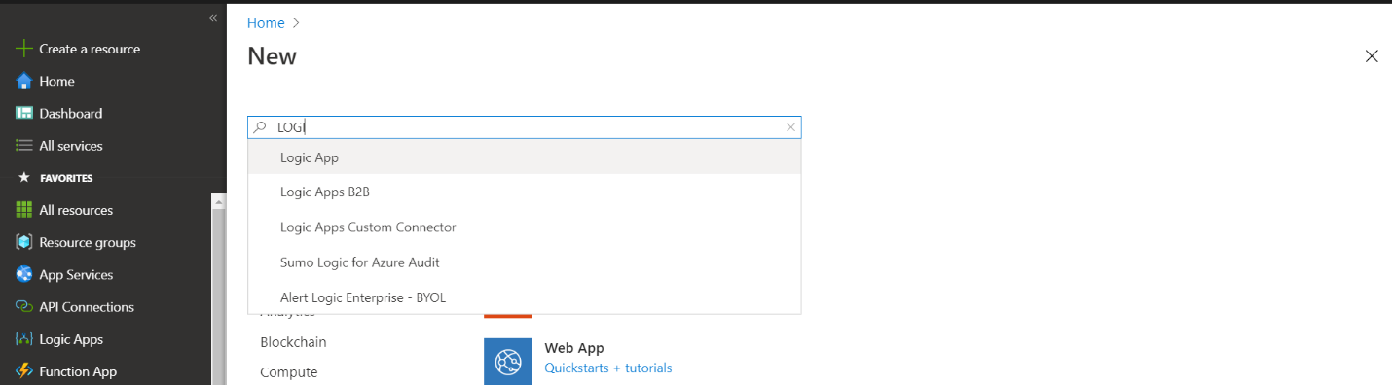

* Click Create and fill in the following details.

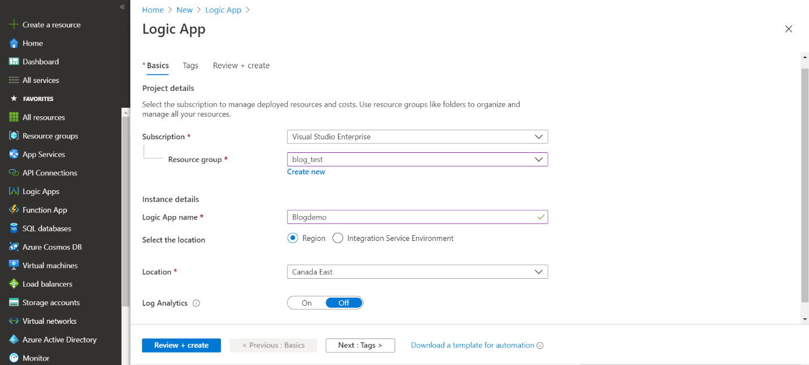

* Once Logic App is deployed. Move to Logic App Designer.
* Choose “when a new tweet is posted”.
* Fill in the search text and time of check in.

**Note**: Twitter will check for Search text whatever you will feed.

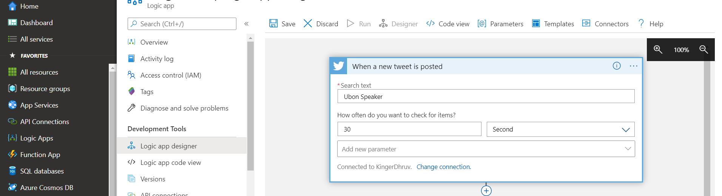

* Next step is to detect sentiment here you will use text analytics API Key. You have to create a connection with that.

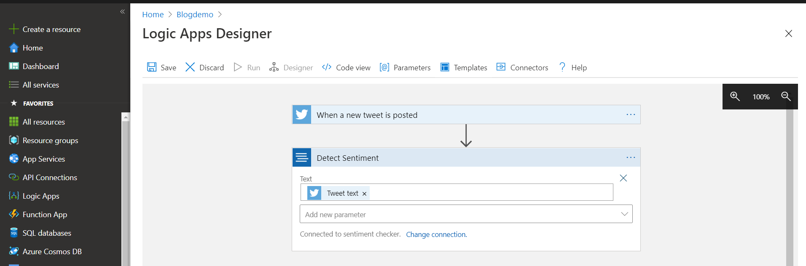

* After that we have to add a condition and fill in as “Score is less than float (‘0.5’).

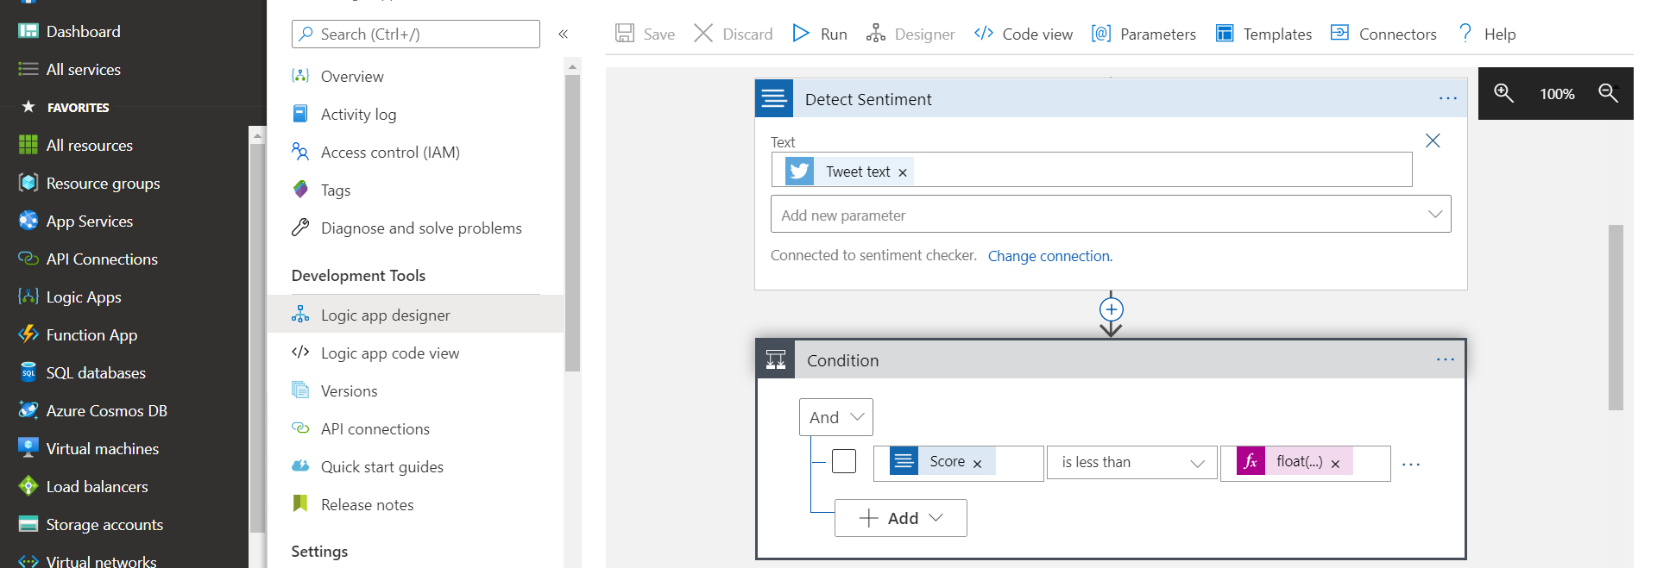

**Note**: For more details see this screenshot below.

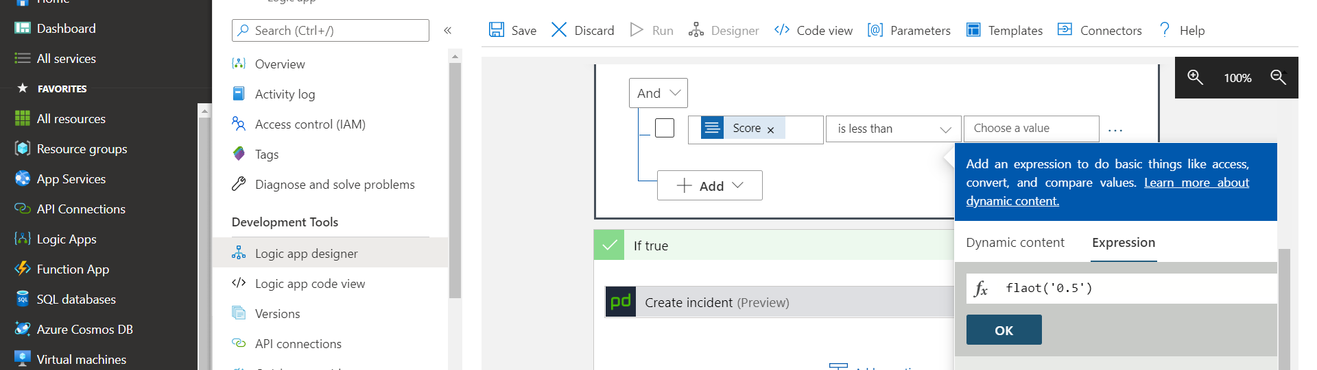

* Now next step is to add “PagerDuty Create Incident Preview”.
* First in order to add Connection you have to paste in 16 character API Key you created above.

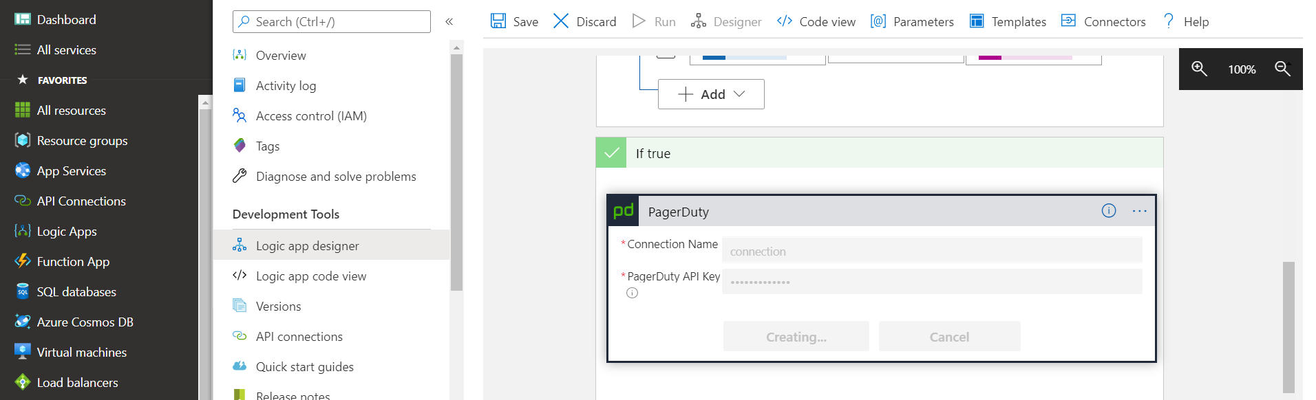

* Next step is to add Service Integration Key. Here you will add 32-character Key.

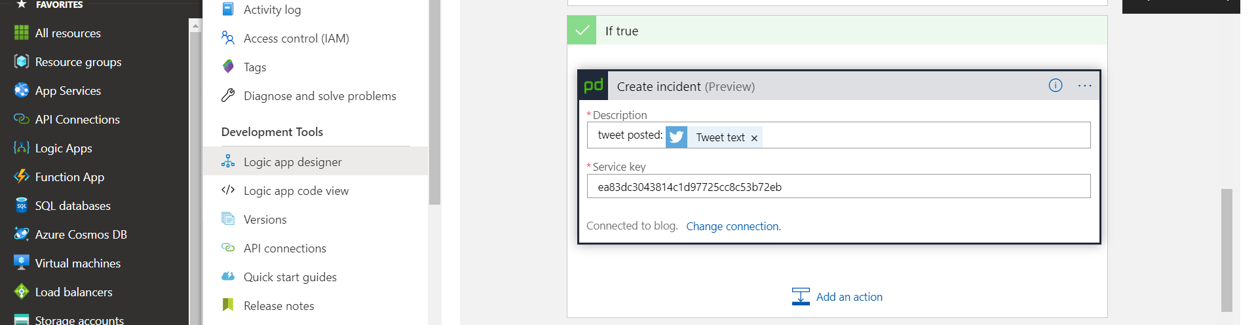

**Task 3**: View Results

1. Save Logic App and run it.
2. Open your twitter account and post any bad text related to entity you are checking your analysis.

# In our scenario I have added Ubon Speaker is not working well !

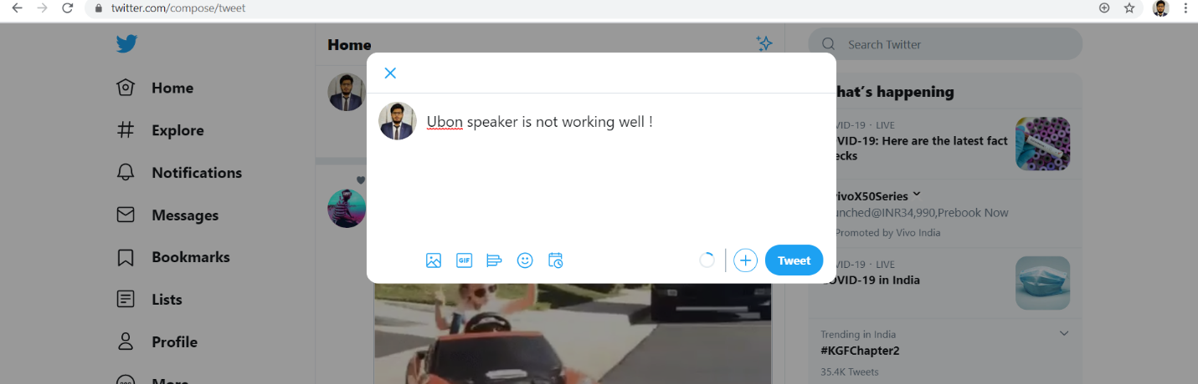

1. See it has successfully ran.

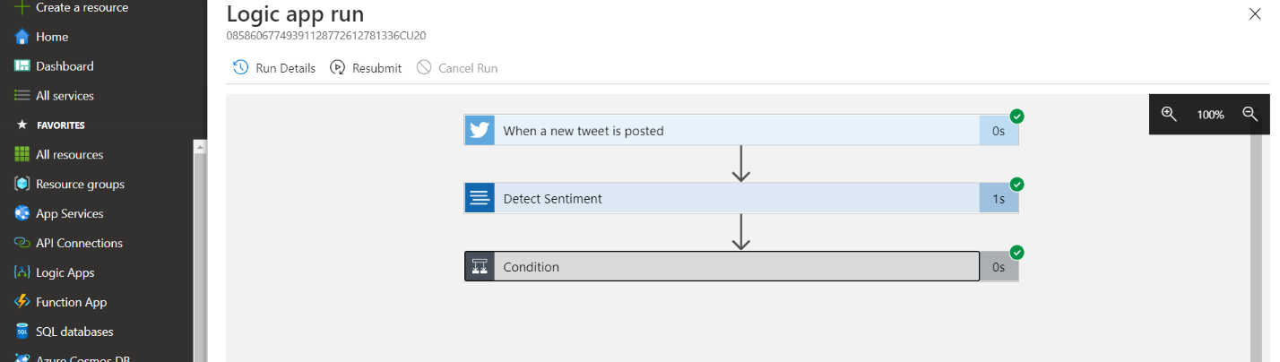

1. Now Let’s see PagerDuty an Incident might be created there.

**Note**: So, we have successfully completed all our tasks. See the Screenshot below for final Verification.

